

**NAME:**

**TEACHER:**

**12 ATMAA Test 3 2020**

**Arithmetic, Geometric**

**and First Order Recurrence Sequences**

**Section 1: / 23**

**Section 2: / 30**

**Total: / 53**

**_________%**

**Material required/recommended for this test**

**To be provided by the supervisor**

Question/answer booklets for Sections One and Two.

SCSA 12ATMAA Formulae Sheet

**To be provided by the candidate**

***Section One:***

Standard items: pens, pencils, pencil sharpener, highlighter, eraser, ruler

*Special materials: drawing instruments, templates, no notes, formula sheet*

**Section Two:**

Standard items: pens, pencils, pencil sharpener, highlighter, eraser, ruler

*Special materials: drawing instruments, templates, notes on a maximum of one unfolded sheet of A4 paper, double sided, up to three approved calculators, CAS, graphics, or scientific.*

**Important note to candidates**

No other items may be taken into the test room. It is **your** responsibility to ensure that you do not have any unauthorised notes or other items of a non-personal nature in the test room. If you have any unauthorised material with you, hand it to the teacher **before** reading any further.

**STRUCTURE OF SECTION 1**

|  |  |  |  |  |  |
| --- | --- | --- | --- | --- | --- |
| Section | Number  of  questions  available | Number  of  questions  to  be  answered | Working  time  (minutes) | Marks  available | Percentage  of Test |
| Section  One:  Calculator-free | 3 | 3 | 23 min | 23 |  |
| Section  Two:  Calculator-assumed |  |  |  |  |  |
| Total | | | | | 53 |

**SECTION 1 CALCULATOR-FREE**

**Question 1 (12 marks)**

1. Given the sequence 4 8, 16, 32, …
   1. Write a recursive rule for the sequence. (2 marks)
   2. Deduce a rule for the *n*th term of this sequence. Hence, calculate the 10th term, leaving your answer in index form. (3 marks)
2. Use the recursive definitions given to state the first **three** terms of each of the following sequences.

(i) *Tn*+1 *= Tn + 5, T*1 *=* 11 (2 marks)

(ii) *Tn*+1 *=* 1.5*Tn , T*2 *=* 4.5 (2 marks)

1. Consider the sequence 12, 7, 2, –3, …

By deducing a rule for the *n*th term, or otherwise, determine which term of the sequence is –183. (3 marks)

Question 2 (4 marks)

The first five terms of an arithmetic sequence are shown on the graph below.

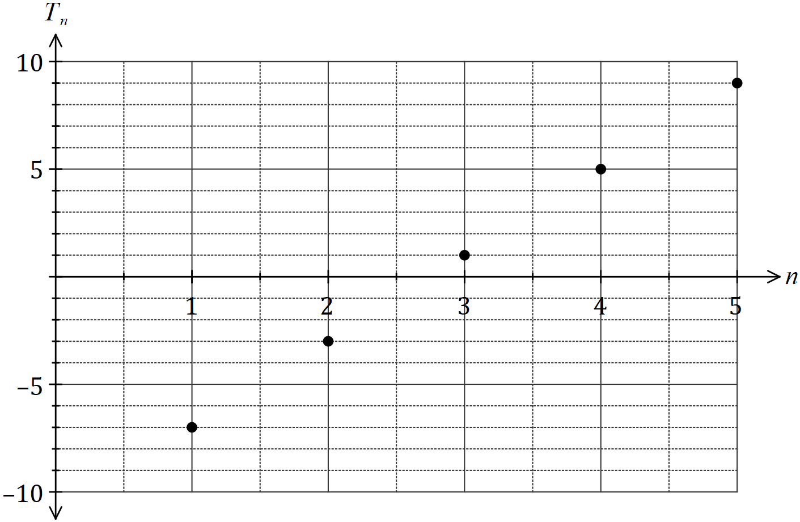

(a) Deduce a rule for the $n^{th}$ term of this sequence. (2 marks)

(b) Given that the $k^{th}$ term of this sequence is $1 197$, determine the value of $k$. (2 marks)

## Question 3 (7 marks)

The population of turtles in an artificial lake at a wildlife sanctuary is initially 32 and research has shown a natural decrease in population of 50% each year. Twenty extra turtles are introduced to the lake at the end of each year.

1. Determine a recursive rule for the turtle population. (2 marks)
2. Determine the long-term steady state of the turtle population. (2 marks)
3. If the wildlife sanctuary preferred a long-term steady state of 80 turtles, what yearly addition of turtles would be required to produce this steady state? Assume all other conditions remain the same.

(2 marks)



**TEACHER:**

**NAME:**

**Section 2: / 30**

**12 ATMAA Test 2 2019**

**Arithmetic, Geometric**

**and First Order Recurrence Sequences**

**CALCULATOR ASSUMED**

***Show all your working clearly.*** *Your working should be in sufficient detail to allow your answers to be checked readily and for marks to be awarded for reasoning. Incorrect answers given without supporting reasoning cannot be allocated any marks. For any question or part question worth more than two marks, valid working or justification is required to receive full marks. If you repeat any question, ensure that you cancel the answer you do not wish to have marked.*

**STRUCTURE OF SECTION 2**

|  |  |  |  |  |  |
| --- | --- | --- | --- | --- | --- |
| Section | Number  of  questions  available | Number  of  questions  to  be  answered | Working  time  (minutes) | Marks  available | Percentage  of Test |
| Section  One:  Calculator-free |  |  |  |  |  |
| Section  Two:  Calculator-assumed | 4 | 4 | 31 min | 30 |  |
| Total | | | | | 53 |

Question 4 (7 marks)

Sequence *T* is defined given by *Tn+1* = 1.25*Tn* , *T*1 = 50 .

1. Use the recursive rule to complete the table below, rounding values to one decimal place. (2 marks)

|  |  |  |  |  |  |  |
| --- | --- | --- | --- | --- | --- | --- |
| n | 1 | 2 | 3 | 4 | 5 | 6 |
| *Tn* | 50 |  |  |  |  |  |

1. Graph the first six terms of sequence *T* on the axes below. (2 marks)

The first three terms of the geometric sequence *U* are 200, 160 and 128.

1. Deduce a rule for the *n*th term of sequence *U*. (2 marks)
2. Determine *U10* (1 marks)

Question 5 (7 marks)

A fish farmer initially stocked a tank with 50 small fish. At the end of each month, the farmer caught some of the largest fish and sold them before adding more, smaller fish to the tank. The number of fish in the tank at the start of the *nth* month is given by *F*, where

*Fn+1*= 0.7*Fn*+ 120, *F1* = 50

1. Use the recurrence relation to state
   1. the number of smaller fish added to the tank each month. (1 mark)
   2. the percentage of the fish caught and sold each month. (1 mark)
2. Graph *Fn* on the axes below for $1≤n≤6 .$ (3 marks)

1. Assuming this model continues, comment on how the number of fish in the tank changes over the next few years. (2 marks)

Question 6 (13 marks)

When Atarcoin, a new cryptocurrency was launched, one Atarcoin was valued at $\$3.00$. After one week of trading, the value of Atarcoin had increased to $\$3.60$, and after another week had increased to $\$4.32$.

(a) Show that the value of Atarcoin increased by $20\%$ each week. (2 marks)

The value of Atarcoin, $V_{n}$ in dollars, $n$ weeks after its launch date, can be modelled by the recurrence relation $V_{n+1}=1.2V_{n}, V_{0}=3$.

(b) Calculate the value of Atarcoin 11 weeks after its launch date. (1 mark)

(c) At the end of which week did the value of Atarcoin first exceed $\$150$? (1 mark)

(d) Graph $V_{n}$ against $n$ on the axes below. (3 marks)

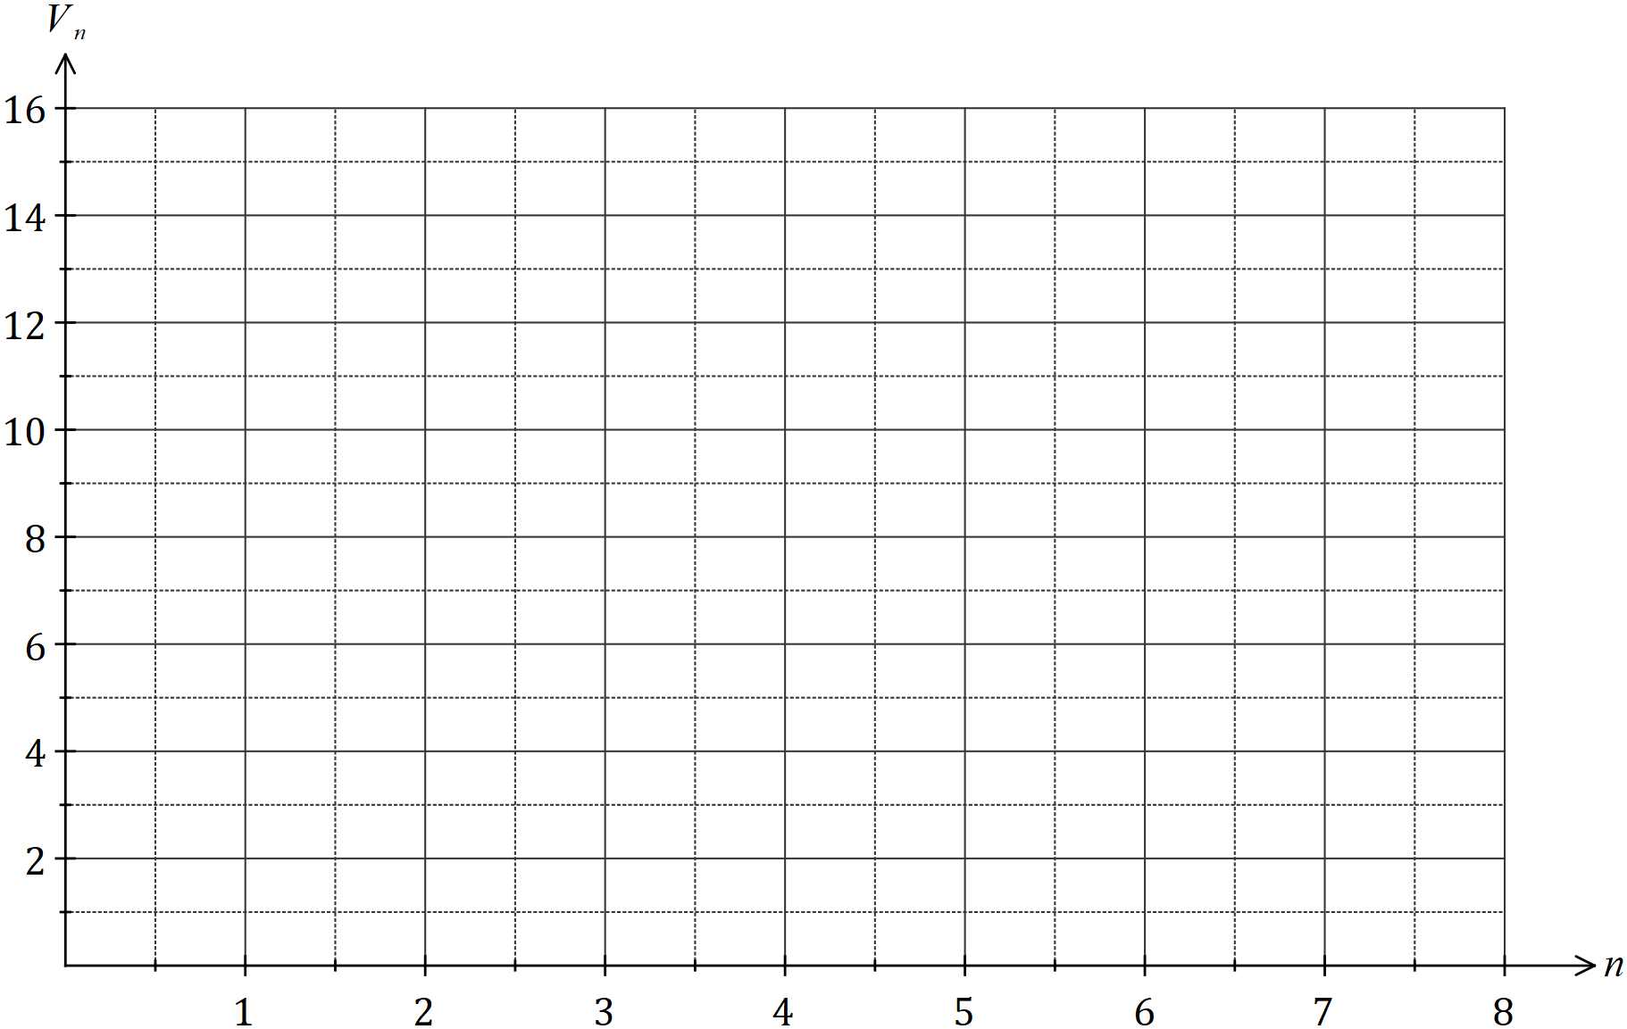

The value of Atarcoin peaked at the end of week $35$, and from that time onwards, its value fell by $40\%$ each week.

(e) Determine the value of Atarcoin at the end of week $36$. (2 marks)

(f) Ignoring any fees involved in buying and selling a cryptocurrency, determine the profit or loss made by a person who bought $150$ Atarcoins four weeks after their launch, held them for $35$ weeks and then sold them all. (4 marks)

# Question 7 (3 marks)

The sequence defined by the recurrence relation tn+l = btn + 38 where t1 = 9, has a long term

steady-state solution of 20. Find the value of b.